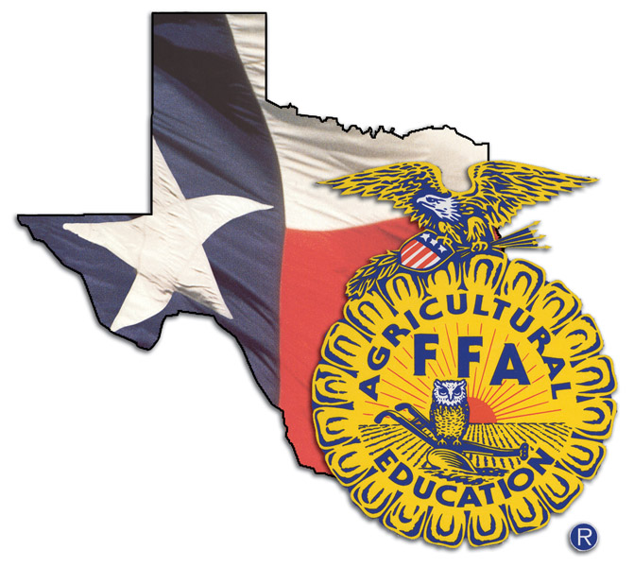

**2019 State Officer**

**Selection Process**

**Preparation Workshops**

**2019 Texas FFA**

**State Officer Selection Process**

**Anyone interested in the State FFA Officer selection process including potential candidates, future state officer candidates, area officer candidates, FFA advisors, parents and anyone else interested in how to prepare for the election process.**

**February 16 James Madison San Antonio**

**February 23 Snyder High School Snyder**

**March 16 Katy High School Houston**

**March 23 Canton High School Canton**

**April 20 Tarleton State University Stephenville**

**9:00 a.m. until 3:00 p.m.**

**Business Casual**

**WHO**

**WHEN**

**&**

**WHERE**

**TIME**

**DRESS**

This workshop will concentrate on preparing state FFA officer candidates for the 2019 selection process. Time will be spent on each of the rounds including: test, writing exercise, personal round: introduction, stand and deliver, facilitation, round robin and personal round: conclusion. We will also discuss the logistics of what will be happening during the selection process and will answer any questions that you may have. Many areas are using pieces of this for their selection process so this will be beneficial to area officer candidates as well.

**Workshop Facilitator: Dr. David Frazier,** Supervisor of the State Process

*If you have questions regarding the workshops, contact Dr. Frazier at* [*frazier@tarleton.edu*](mailto:frazier@tarleton.edu) *or at 325.660.4663*

Register on judgingcard.com

*There is NO registration fee; however, you will be responsible for your own lunch!*

*You may register and attend one or all of these workshops.*

**What will you need at the workshop?**

You will need to bring a copy of the state officer handbook (available online at Texas FFA), paper to take plenty of notes and a positive attitude!!